|  |
| --- |
| Golden Pixie Gaming |
| **Skippy Tree Climber** |
| Viva La Squirrel (GDD) |
| Version #1.0  All work Copyright © 2022 by Golden Pixie Gaming.  All rights reserved. |
| **[Philip Henderson]** |
|  |

|  |
| --- |
| November 8th 2022 |

Table of Contents

Version History 3

Game Overview 4

Game Play Mechanics 4

- UI Panel 4

Camera 4

Controls 4

Saving and Loading 4

Interface Sketch 5

Menu and Screen Descriptions 5

Game World 5

Levels 6

Game Progression 6

Characters 6

Enemies 6

Weapons 6

Items 7

Script 7

Scoring 7

Sound Index 7

Art / Multimedia Index 8

Future Features 8

# Version History

v - 1.0 – November 8th 2022

# Game Overview

* This game will be up Upward scroller type game where the squirrel will have to avoid enemies like owls and hawks as you climb.
* Using the platforms to jump, evade the fox constantly approaching from the bottom of the screen
* A timer for the level will increase incrementally accordingly as you progress
* Survive the timer to pass the level
* acorns collected(points) will be multiplied by the score from killing enemies(kills) to give you a final score(total) for each level, totaling all level scores at the end of the game (end game total).

# Game Play Mechanics

* A UI Panel at the bottom of the screen will house 2 arrows, a jump button, a shoot button and a menu button

### UI Panel

* *2 Arrows – left and right movement*
* *Jump Button – make you go higher*
* *Shoot Button – Shoot enemies like owl and hawks*
* *Menu Button – Change Audio Settings, Restart or Quit*

# Camera

* *2D Platformer*

# Controls

* *Mobile Touch Screen*

# Saving and Loading

*(Does your game include saving and loading? When? How?)*

* *Will save your past score in a high score list*
* *At the end of each game, your score will be placed onto a key in the registry (PlayerPrefs)*

*and called upon when High Score screen is activated*

* *Using a sorting algorithm, the program will place scores into the display list appropriately*

# Interface Sketch

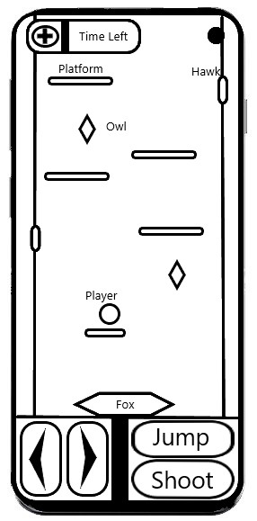

**Main Menu Instructions Play Screen Game Over**

# Menu and Screen Descriptions

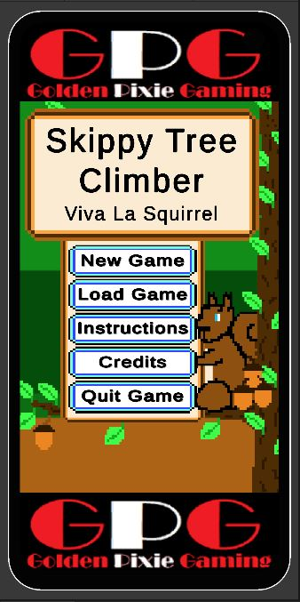

# Game World

* Playing as a squirrel, you are climbing between 2 endless trees that have branches the player can use as 1 form of platform
* With bright colors and a scrolling upwards background
* Tree bark will be varying shades of brown, where leaves will be varying shades of green
* The bottom of the play area (right above the bottom UI elements) will have a fox head, facing upward with only the front/top of the fox’s head in view
* Platforms will consist of tree branches, falling tree branches and flying squirrels
  + Tree branches(stationary)
  + Falling Tree Branches(Fall after a couple seconds)
  + Flying Squirrels(move horizontally across the screen as a temporary platform)

# Levels

* *Each level will have the same basic concept of avoiding falling and colliding with the bottom of the play area, thus getting eaten by the fox*
* *As the player progresses*
  + *the timer for each level will get longer*
  + *the speed in which the fox moves will increase faster*
  + *platforms will get less frequent, removing the possibility for easy jumps*
  + *Level backgrounds will change slightly showing it getting later in the day till its nighttime*

# Game Progression

* To beat each level, just stay alive
* Avoid falling to the bottom of the play area and getting eaten
* If you survive the timer, you will progress to the next level

# Characters

* The avatar is a brown squirrel with a big bushy tail and blue eyes
* *He will run and jump as directed to attempt to survive*

# Enemies

* Fox
  + Main Game Enemy
  + Placed at the bottom of the play area
  + Gives the impression that it’s moving upward due to the scrolling background
  + If the player gets to close to the bottom of the screen, the fox’s mouth will open wider
* Owl
  + Stationary Enemy
  + Floats in place and hurts player if collided with
  + Has a short flying animation
* Hawk
  + Attacking Enemy
  + There will also be Hawks perched at the side of the screen on branches(platforms), if the player gets to close, it will swoop towards the player after making a short pre attack animation to let the player know that it will attack in a few seconds and to beware

# Weapons

* The player will be able to shoot acorns straight forward from there facing orientation

# Items

* *The player will also be able to collect acorns as coins or points that will increase their final score*

# Script

* Player Controller Script
  + Movement
  + Shooting
* Game Manager Script
  + Game Over
  + Save Score
* Enemy Script
  + Behaviour
  + Spawning
* Scrolling Background Script
* Main Menu Script
  + Load Game
* UI Script
  + HP
  + Timer

# Scoring

**How to Get Points**

* Killing Enemies
* Collecting Acorns

*At the end of each game, your score will be placed onto a key in the registry (PlayerPrefs)*

*and called upon when High Score screen is activated*

# Sound Index

* Main Menu Music
* *Play Scene Music*
* *Player Sounds*
  + *Jumping (spring noise)*
  + *Running (shuffle noise)*
  + *Shooting (pew pew noise)*
  + *Dying (“Uh ohhh” in a cute voice)*

# Art / Multimedia Index

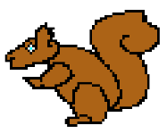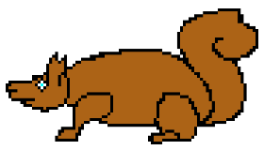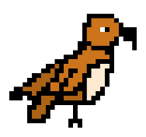

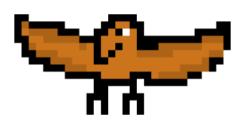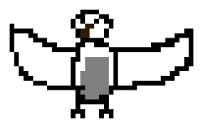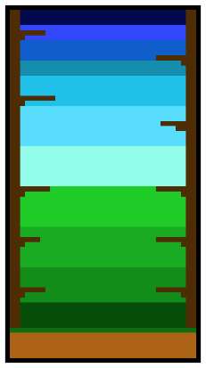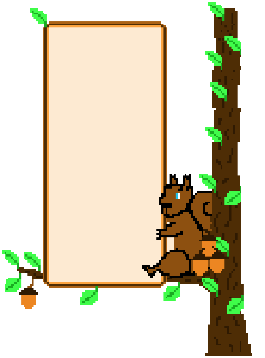

# Future Features

*(Include any future features that are planned to be implemented)*

* *Going to implement more levels*
* *Going to implement power ups, e.g player invincibility or jump height increased for a short time*